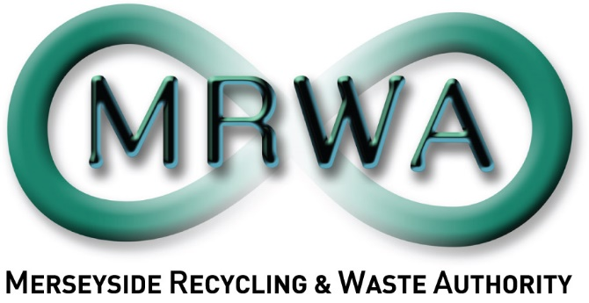

Phase 2 Community Textile Project: Application Form
May 2024 – February 2025

Pack includes:
- Your Organisation
- Meeting the Project Objectives
- Finance
- Evaluation
- Conflict of Interest
- Other Issues
- Appendix 1: Timescales
- Appendix 2: Scoring Evaluation

Applications must be sent to laura.gilmore@merseysidewda.gov.uk by 5pm on the 30th June 2024. If you have any questions, please contact laura.gilmore@merseysidewda.gov.uk.

Please ensure to read all of the associated documents entirely before completing this application.
Title of Project:
Date of Proposal:
 | 1.1 | Name of the organisation making this proposal. If you are working in partnership, please list all partners and indicate who will be the lead partner.
 | 1.2 | Contact name, and email address for enquiries about this proposal. If this is a partnership proposal, please list the lead contact.
 | 1.3 | If applicable, please provide your charity or company number below.
 |  | Company Number: |  | Charity Number:

- About your Organisation(s):

- Meeting the Project Objectives:
This section evaluates your skills and experience in relation to the specific project objectives.
  - What areas would you be focus on?
Please indicate which districts within the LCR you would like your workshops to be held.

Knowsley
St Helens
Halton

2.2 What links within the community do you/your organisation have or intend to make to promote this project?
2.3 What is the intended audience of your project?
Please give approximate numbers you expect to have in attendance.

  - Textile Reuse / Circular Economy knowledge and understanding.
Please tell us your/your organisations experience/knowledge in the topics of textile reuse and upcycling and the concepts of Circular Economy. (Max 500 words.)

  - Project Planning and Delivery
Please tell us about your experience in delivering community workshops, developing engaging resources, and planning and running an engaging event.

Educational workshops:
Developing resources:
Planning, organising, and running an event.

  - Design of project:
Please share your plans for how to deliver the MRWA Textile Reuse Project 2024-25. This should include a project overview, desired outcomes, target audience and any other relevant details.

  - Implementation Plan and Timetable
Please describe each task you will undertake to deliver the project within time scales, ensure to show the key tasks involved in delivering the project, including when each task will happen, and demonstrating how the work will fit the planned start and finish date. This can be done in table or word format.

- Finance:
This section covers the financial request for the Community Textile Reuse Pilot Project. There is £2,000 per district available, organisations wishing to support multiple areas can combine the funding for each additional district up to a total of £6,000 for all three areas.
3.1 Your Organisation
Please indicate the amount which your organisation wishes to quote in order to deliver the project:
Total:
(Please remember we are supportive of paying Living Wage to any employees involved in delivering services as part of this contract.)

3.2 Cost Breakdowns
 | Please provide a breakdown of these costs in the following table:
Eligible costs will include:
- Event costs: costs associated with hosting a successful event such as venue hire, materials, equipment/machinery purchase or rental, consultant fees.
- Staff time: for activities associated with the project, such as meeting MRWA and other partners if required, understanding the engagement tasks, designing and carrying out the engagement, writing a report, presenting feedback and demographics of participants to MRWA, feeding back to community (if required) the way in which their input has been used by MRWA.
- Other costs: for activities associated with the engagement activity such as printing/photocopying, participant expenses/alternative, volunteer expenses and training, refreshments, childcare or other carer support costs, translation/production of information in alternative formats, appropriate support for participants in responding to issues arising in the engagement, film/photography, equipment etc.
- Contribution to management and overhead: for costs up to a maximum of 10% of the value of the overall cost.

 |  |  | Costs: | Hourly Rate: | No. of Hours: | Total Cost £:
 | 3.2a |  | Event Costs: please provide details for expenses incurred in the planning and hosting of the event(s) themselves:
 | 3.2b |  | Staff Time: please provide details for which staff would be involved for how much time:
 | 3.2c |  | Other Costs: please list costs associated with delivery and reporting
 | 3.2d |  | Management Overheads:  (Max 10%)
 |  |  | Total Costs:

- Evaluation
Please explain why your organisation is best placed to deliver this project: (Max 250 words)

- Conflict of Interest
5.1 Please indicate whether any known actual or potential conflicts of interest may arise in the provision of carrying out this engagement.

 | Potential Conflict: |  | No Conflict:
If there are actual or potential conflicts, please provide full details including:

- Brief description of the nature of connections creating actual or potential conflicts of interest.
- The full name of any people or bodies whose involvement gives rise to the actual or potential conflicts of interest.
- Mark with an (*) an organisation, people or bodies that are connected with MRWA.
- An explanation of how the Applicant proposes to deal with actual or potential conflicts so that they do not prejudice a fair and competitive procurement process or the position of MRWA.

5.2 Please indicate whether your organisation, or partners, have been recipients of MRWA and Veolia’s 2024-2025 Zero Waste Community Fund.

 | Yes |  | No
If your organisation, or partners, have been recipients of MRWA and Veolia’s 2024-25 Zero Waste Community Fund, please provide details including:

- Title of successful Zero Waste Community Fund 2024-25 project
- Confirmation there is no overlap between this project and your community fund project
Please note if you have successfully been awarded any funding from MRWA and Veolia’s Zero Waste Community fund 2024-2025, you must show evidence there is no overlap of delivery with Phase 1 Circular Economy Pilot Project, including participants, targets, or engagements.

- Other Issues: Not for scoring.
Please use this space to highlight any other useful information for MRWA to consider in this project. (Max 150 words)

Please note the selected organisation will be expected to have all of the necessary accreditation/checks in place to undertake this project as described.

Appendix 1: Time Scales
Activity Detail: | Dates:
Project tender goes live | 31st May 2024
Project tender closes | 30th June 2024
Organisation selected | By 12th July 2024
Due diligence | Following acceptance
Project initiation meeting | w/c 15th July 2024
Final reports received | 28th February 2025

Appendix 2: Scoring Table
Score: | Scoring Principles:
5 | Excellent – there is ample evidence to support the response.
4 | Good – there is sufficient evidence to support the response.
3 | Average – there is some evidence to support the response.
2 | Fair – there is little evidence to support the response.
1 | Poor – there is no evidence to support the response.
0 | Very poor – there is no evidence to support the response.

