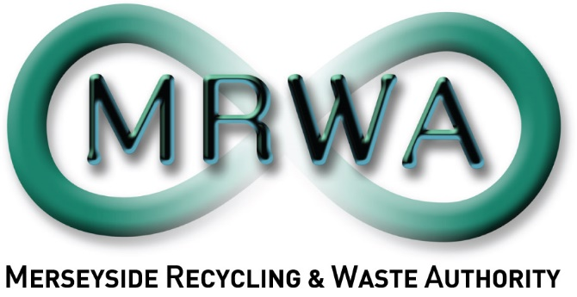

Phase 2 Community Textile Pilot
Project Tender:
May 2024 – February 2025

Phase 2 Community Textile Project
Background
Merseyside Recycling and Waste Authority (MRWA) are responsible for the treatment and disposal of household waste in Liverpool City Region (LCR). As the statutory Authority we work with all the local councils in Liverpool City Region – Halton, Knowsley, Liverpool, Sefton, St Helens, and Wirral.
At MRWA we are committed to working towards both our own Corporate Plan and the targets of zero waste and net zero carbon by 2040. In order to achieve this target and combat the effects of climate change we must ensure resources are used for longer and their value can be maximised by the local economy.
MRWA wishes to work with our partners to make Liverpool City Region a place where all materials are valued as usable resources and that nothing goes to waste – we need to waste less, and reuse, repair, share and recycle more.
What will your organisation’s participation involve?
According to a recent analysis, around 5% of household bins on Merseyside contained textiles such as clothes and shoes. (Statistic from Merseyside and Halton Waste Composition Analysis 2021/22)
With this in mind, MRWA wishes to appoint an organisation or individual to develop and deliver a range of community-based textile workshops. The aim of these sessions are to promote textile re-use across the Liverpool City Region, providing education and resources to support this. Sessions may include but are not limited to,
- clothing swishes,
- printing or dyeing sessions,
- sewing classes,
- tailoring and upcycling workshops,
- textile craft or quilting sessions.
Specifically, taking part would involve the following:
Help us link in with local community groups and spaces - As you will have good connections within the community, we would welcome your help in linking with residents, venues, and organisations to spread the key waste reduction messages and deliver a range of workshops covering textile reuse in some capacity.
Deliver textile waste reduction workshop(s) – You will be expected to plan and deliver up to events in up to three districts, covering specific areas of the Liverpool City Region that were not covered in phase 1 of the project (districts include, Knowsley, St Helens, and Halton). These events can be tailored to your local residents and venue as long as they promote textile reuse in some capacity. You will be responsible for the complete management and delivery of the workshops including the sourcing of materials, venues, staffing and attendees.
Help us share the message of reuse, recycling and promoting a circular economy – You will create and develop resources and toolkits that support the message of textile reuse and recycling that are suitable for your target audience and complement your event. This could include;
- Promotional materials such as posters and leaflets
- Educational resources such as how to guides, tips and tricks etc.
- Photographs and social media content
- Attendee questionnaires or feedback forms
Collect data to evaluate effectiveness – To instigate behaviour change we need to understand attitudes and barriers. We’d like you to gather information from groups prior to workshop delivery and on completion of participation to determine the effectiveness and response to sessions like this.
Produce project evaluation – Following completion of the project(s) you should produce a report which should include the following:
- Summary of the project, including outcomes.
- Attendance figures and feedback from staff and attendees.
- Successes and learning points from this project.
- Recommendations for how we can improve or develop this project.
Project outcomes
We’re looking for the following outcomes for this project:
- Delivery of a minimum of one textile project per provider to cover each of the three districts (multiple appointees may be required).
- Development of resources and activities that support the message of textile reuse.
- Impact reporting such as community response, amount of textiles utilised and attendance of each event.
- Evaluation/end of project report
How your organisation can benefit from taking part in the project
Help instigate behaviour change – We want to shift from a linear to a circular economy, and minimise waste across the LCR, to do this successfully we engage with residents and work in partnership with community groups and organisations.
Embed reuse and circular economy thinking within your organisation - Develop new/ additional skills and resources within your organisation.
Provide opportunities for people to access clothing and learn about upcycling and reuse – Help support understand of waste issues within the textile industry and importantly how we can work together locally to tackle these issues while supporting our community.
Develop new partnerships and networking links – build up relationships with a range of Local Authorities, Community Groups, Education providers and other organisations.
Provide social value for the LCR communities - we’re looking to reach a range of individuals and age groups including forgotten communities, and to maximise social value.

Funding linked to the Project
Organisations can bid for up to £2,000 funding for each district covered, with a maximum of £6,000 available to cover all three of the available areas, (this must cover all associated costs including venue hire, event management fees, materials, and any additional expenses). As per policy all payments will be paid on completion of the project. Districts included in phase 2 of the project includes, Knowsley, Halton and St Helens.
Applications are open to organisations wishing to cover between one and three districts. These applications will be scored in line with the criteria and awarded based on best value for each district. This may result in some districts remaining un-funded after the first round, and in this case we will re-issue funding for the remaining specified districts.
When will the project be delivered?
This contract is for a four-month period to run from May 2024 to 31 January 2025.
Published | 31st May 2024
Deadline for tenders | 30th June 2024
Supplier notified of award of contract | By the 12th July 2024
Project Initiation Meeting | w/c 15th July 2024
Project End Report Due | 28th February 2025
Evaluating applications
We will score applications received based on
- 60% Meeting project brief
- 20% Finance
- 20% Evaluation
How to apply
To apply, please download and complete the commissioning proposal form below and send to laura.gilmore@merseysidewda.gov.uk by 5pm 30th June 2024. If you have any questions, please contact laura.gilmore@merseysidewda.gov.uk .

