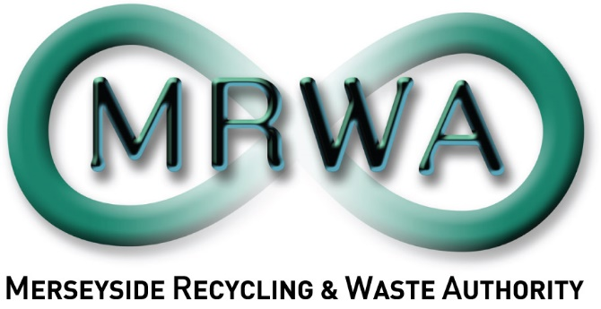

Community Reuse and Repair Project

Application Form

June 2024

Pack includes:
- Your Organisation
- Meeting the Project Objectives
- Finance
- Evaluation
- Conflict of Interest
- Other Issues
- Appendix 1: Timescales
- Appendix 2: Scoring Evaluation
Applications must be sent to laura.gilmore@merseysidewda.gov.uk by 5pm Sunday 14th July 2024. If you have any questions, or would like to co-ordinate a discussion prior to application please contact laura.gilmore@merseysidewda.gov.uk
Please ensure to read all of the associated documents entirely before completing this application.
- About your Organisation(s):

  - Name of the organisation making this proposal. If you are working in partnership, please list all partners and indicate who will be the lead partner.

  - Contact name, and email address for enquiries about this proposal. If this is a partnership proposal, please list the lead contact.

  - If applicable, please provide your charity or company number below.

Company Number: |  | Charity Number:

Application
Title of project:
Date of proposal:

- Meeting the Project Objectives:
This section evaluates your skills and experience in relation to the specific project objectives.
  - Community Links, Focus and Local Demand -
What links do you have or plan to make within the community to support your scheme? Do you have a set target demographic? Which areas of Liverpool City Region do you aim to support? As we will have applicants from across the City Region, please demonstrate the need for this scheme within your area, what other provisions if any are available locally and how do you differ from them.

- Please estimate the total number of households and residents you expect to engage with and an estimate of the repairs you would be able to undertake.
Nº Participants | Nº Repairs

2.2 Knowledge and Experience –
A. Knowledge and Experience around repair and reuse
Please tell us your experience/knowledge in the topics of repair and reuse. What makes you/your partnership the best suited to host a repair scheme. (Max 500 words).

B. Project Planning and Delivery Experience
Please tell us about your relevant experience in delivering workshops, developing engaging resources, and planning, setting up and running a community projects.

2.3 Design of pilot project:
Please share your plans for this scheme and its delivery, including its potential and longevity outside of this funding. We can only score what is provided so please be as detailed as possible around aims, outcomes and content. If you would like to include additional documents, please email these alongside your application.

2.4 Implementation Plan and Timetable
Please describe each task you will undertake to deliver the project within time scales, ensure to show the key tasks involved in delivering the project, including when each task will happen, and demonstrating how the work will fit the planned start and finish date.
- Finance:
This section covers the financial request for the Community Reuse and Repair Project.
3.1 Your Organisation
Please indicate the amount which your organisation wishes to quote in order to deliver the project:
Total:

(Please remember we are supportive of paying Living Wage to any employees involved in delivering services as part of this contract.)

3.2 Cost breakdowns
Please provide a breakdown of these costs in the following table or on an additional document. As this is 40% of your scoring it is important to be as detailed as possible, subheading such as equipment will score lower than specific named products and costings.
 | Costs. | Hourly rate: | No. of hours: | Total costs £:
3.2a | Repair Scheme: please provide details around direct project launch costs.
3.2b | Staff/Volunteer Time: please provide details for which staff/volunteers would be involved for how much time:
3.2c | Other Costs: please list costs associated with delivery and reporting:
Management Overheads:
(Max 10%)

 | Total Costs:

- Evaluation

Please explain why your organisation is best placed to deliver this project: (Max 250 words).

- Conflict of interest

  - Please indicate whether any known actual or potential conflicts of interest may arise in the provision of carrying out this engagement.
Potential Conflict: |  | No Conflict:

If there are actual or potential conflicts, please provide full details including:
- Brief description of the nature of connections creating actual or potential conflicts of interest.
- The full name of any people or bodies whose involvement gives rise to the actual or potential conflicts of interest.
- Mark with an (*) an organisation, people or bodies that are connected with MRWA.
- An explanation of how the Applicant proposes to deal with actual or potential conflicts so that they do not prejudice a fair and competitive procurement process or the position of MRWA.

  - Please indicate whether your organisation, or partners, have been recipients of MRWA and Veolia’s 2024-2025 Community Fund.
Yes: |  | No:

If your organisation, or partners, have been recipients of MRWA and Veolia’s 2024-25 Community Fund, please provide details including:
- Title of successful Community Fund 2024-25 project
- Confirmation there is no overlap between this project and your community fund project.

Please note if you have successfully been awarded any funding from MRWA and Veolia’s Community fund 2024-2025, you must show evidence there is no overlap of delivery with this Community Reuse and Repair Project, including participants, targets, or engagements.
- Other Issues: Not for scoring.

Please use this space to highlight any other useful information for MRWA to consider in this project. (Max 150 words).

Please note the selected organisation will be expected to have all the necessary accreditation/checks in place to undertake this project as described. For those aiming to launch as part of the scheme these will need to be factored into the early stages of the timeline to ensure the project can move forward.

Appendix 1: Time Scales

Activity Detail: | Dates:
Project tender goes live | 14th June 2024
Meeting request window closes | 8th July 2024
Project tender closes | 14th July 2024
Tender applications evaluated | w/c 15th July 2024
Organisation selected | 19th July 2024
Due diligence | Following acceptance
Project initiation meeting | w/c 22nd July 2024
Final reports received | February 2025

Appendix 2: Scoring Evaluation

Score: | Scoring Principles:
10 | Excellent – there is ample evidence to support the response.
8 | Good – there is sufficient evidence to support the response.
6 | Average – there is some evidence to support the response.
4 | Fair – there is little evidence to support the response.
2 | Poor – there is no evidence to support the response.
0 | Very poor – there is no evidence to support the response.

